Smart Traffic Violation Logger (Flask)
Flask-Based Traffic Challan Management System
Author: Artheesh E
Project Type: Individual Project

1. Executive Summary
The Smart Traffic Violation Logger with QR-Based Challan System is a Flask-based web application designed to digitally manage traffic violations. It allows officers to record violation details such as vehicle number, type, location, date, and fine amount, with each entry stored in a database and marked as unpaid by default.
The system includes features to search records, update payment status, and generate QR codes for each challan, enabling quick access to violation details through a public page. Overall, it improves efficiency, accuracy, and transparency compared to traditional manual systems.

2. Project Objective & Scope
The scope of this project includes the design and development of a functional web application that supports core features such as adding violation records, viewing and searching history, updating payment status, and generating QR codes for each challan. The system uses a local database (SQLite) for data storage and provides a user-friendly interface using Bootstrap.
The project is limited to a basic implementation suitable for learning and demonstration purposes. Advanced features such as online payment integration, AI-based violation detection, and large-scale deployment are not included but can be added in future enhancements.

3. Technical Implementation
The Smart Traffic Violation Logger with QR-Based Challan System is implemented using a simple and efficient full-stack approach based on Flask.
🔹 Backend (Flask)
The backend is developed using the Flask framework in Python. It handles routing, request processing, and communication between the frontend and database. Flask routes (@app.route) are used to manage functionalities such as adding violations, viewing records, updating status, and displaying QR-based pages.

🔹 Database (SQLite + SQLAlchemy)
The application uses SQLite as the database for storing violation records.
SQLAlchemy is used as an ORM to define database models and perform CRUD operations.
Example fields:
- Vehicle Number
- Violation Type
- Location
- Date
- Fine Amount
- Status (Paid/Unpaid)

🔹 Frontend (HTML, CSS, Bootstrap)
The user interface is built using HTML and styled with Bootstrap to ensure a responsive and clean design. Forms are used to collect user input, and tables are used to display violation records.

🔹 QR Code Generation
QR codes are generated dynamically using a Python library (like qrcode). Each QR code contains a URL that redirects to a public page displaying violation details and payment status.

🔹 Core Functional Modules
- Add Violation
  - Form submission using POST method
  - Data stored in database
- View/Search Records
  - Retrieve data using queries
  - Filter by vehicle number, date, or type
- Update Status
  - Modify record status (Unpaid → Paid)
- QR-Based Public Page
  - Unique route for each violation
  - Displays details when QR is scanned

🔹 Deployment (Basic)
The project can be run locally using Flask’s development server (app.run(debug=True)). It can also be deployed on platforms like Render or PythonAnywhere for online access.

SOURCE CODE IMPLEMENTATION (Screenshot):
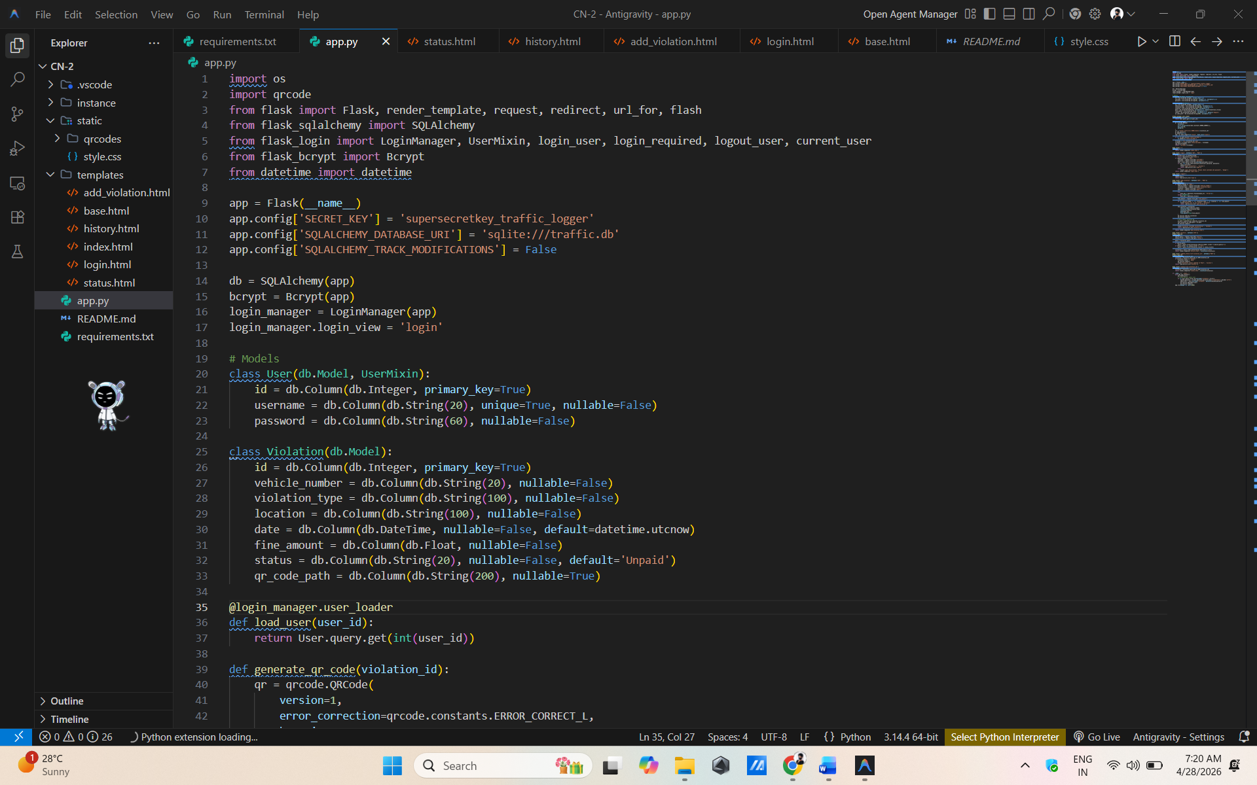

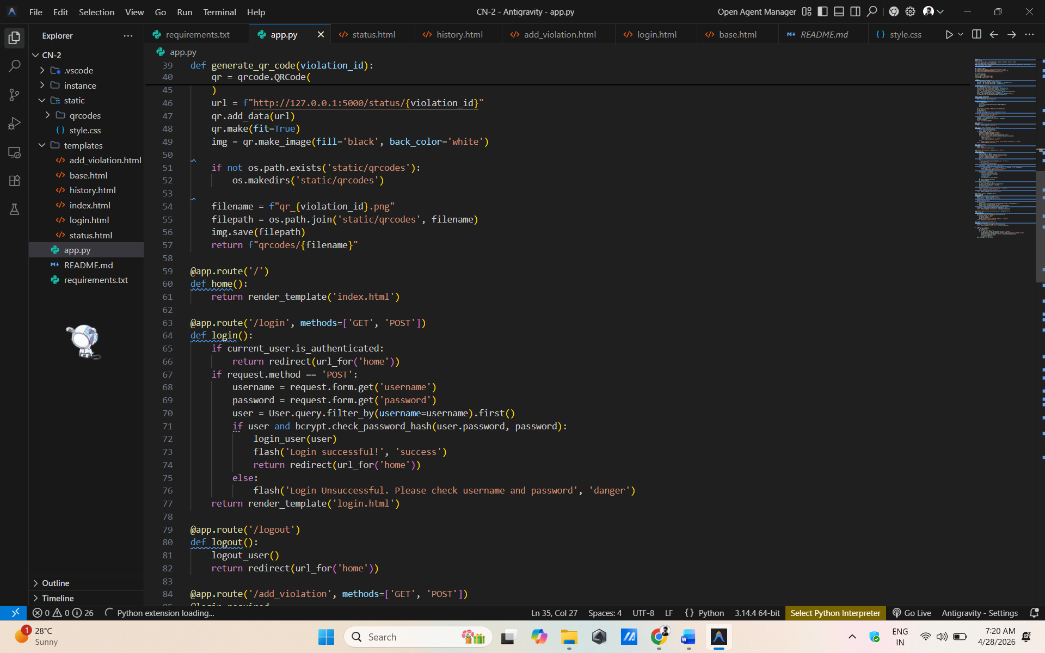

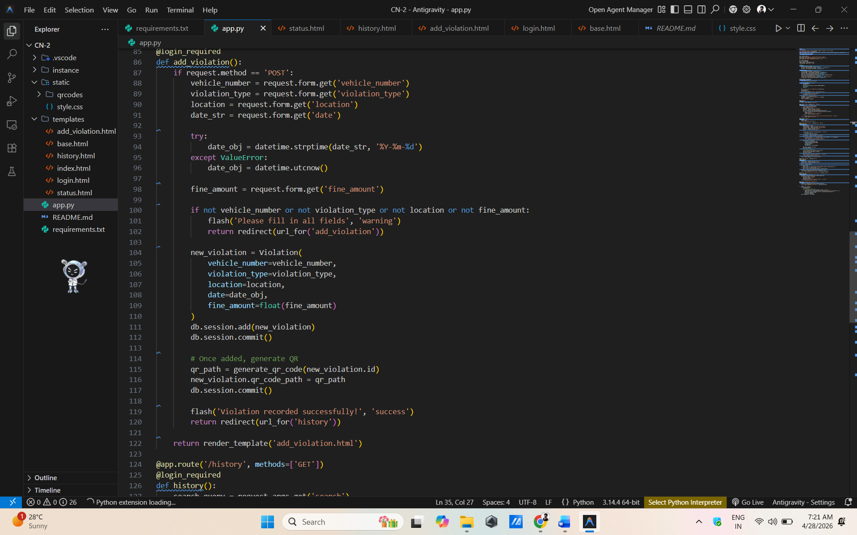

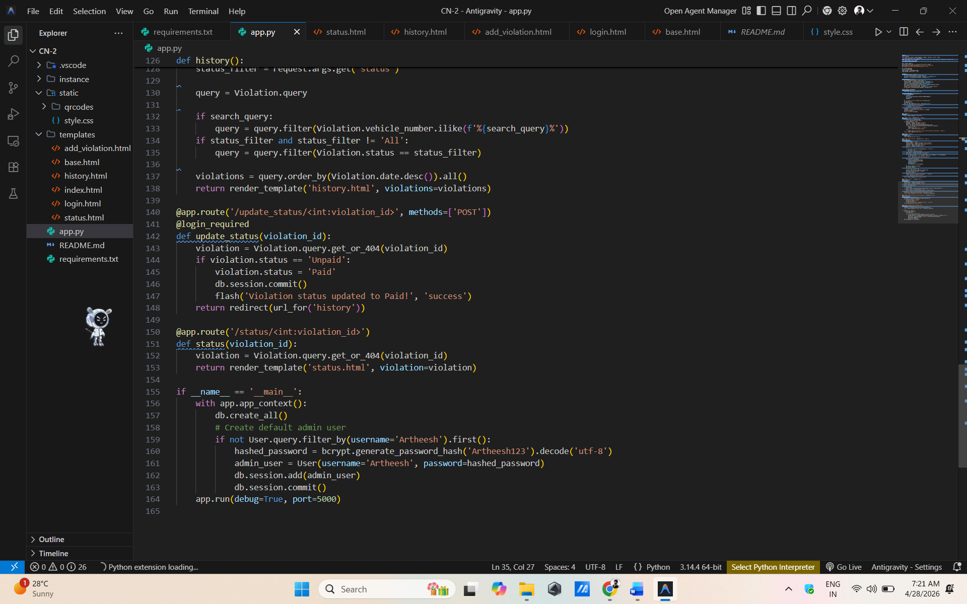

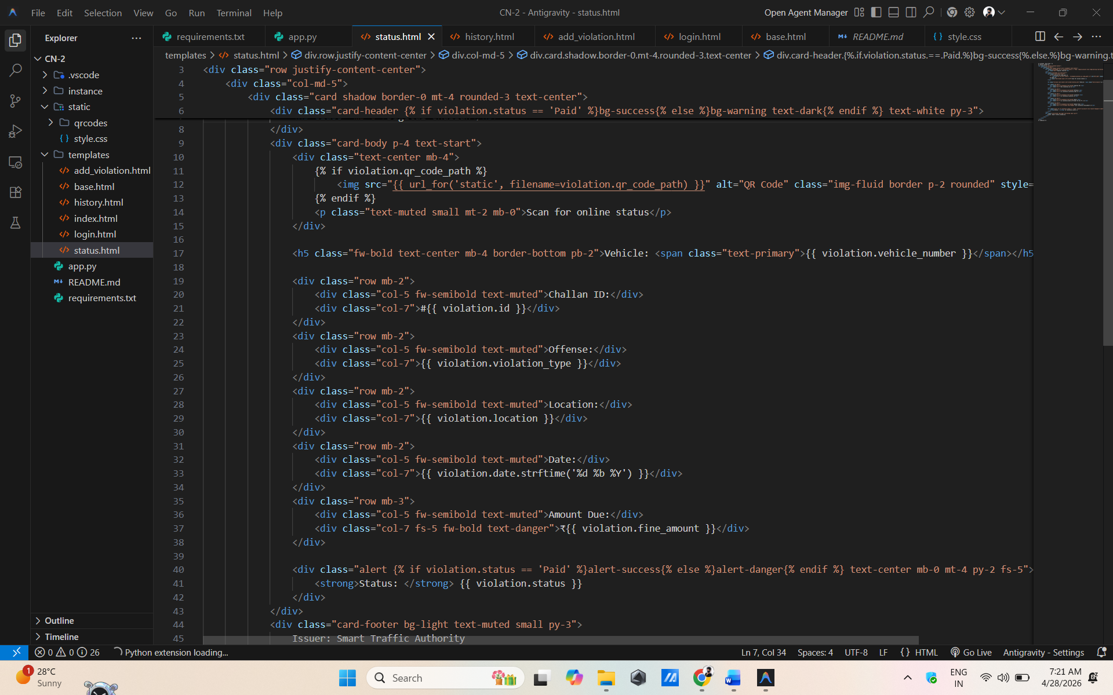
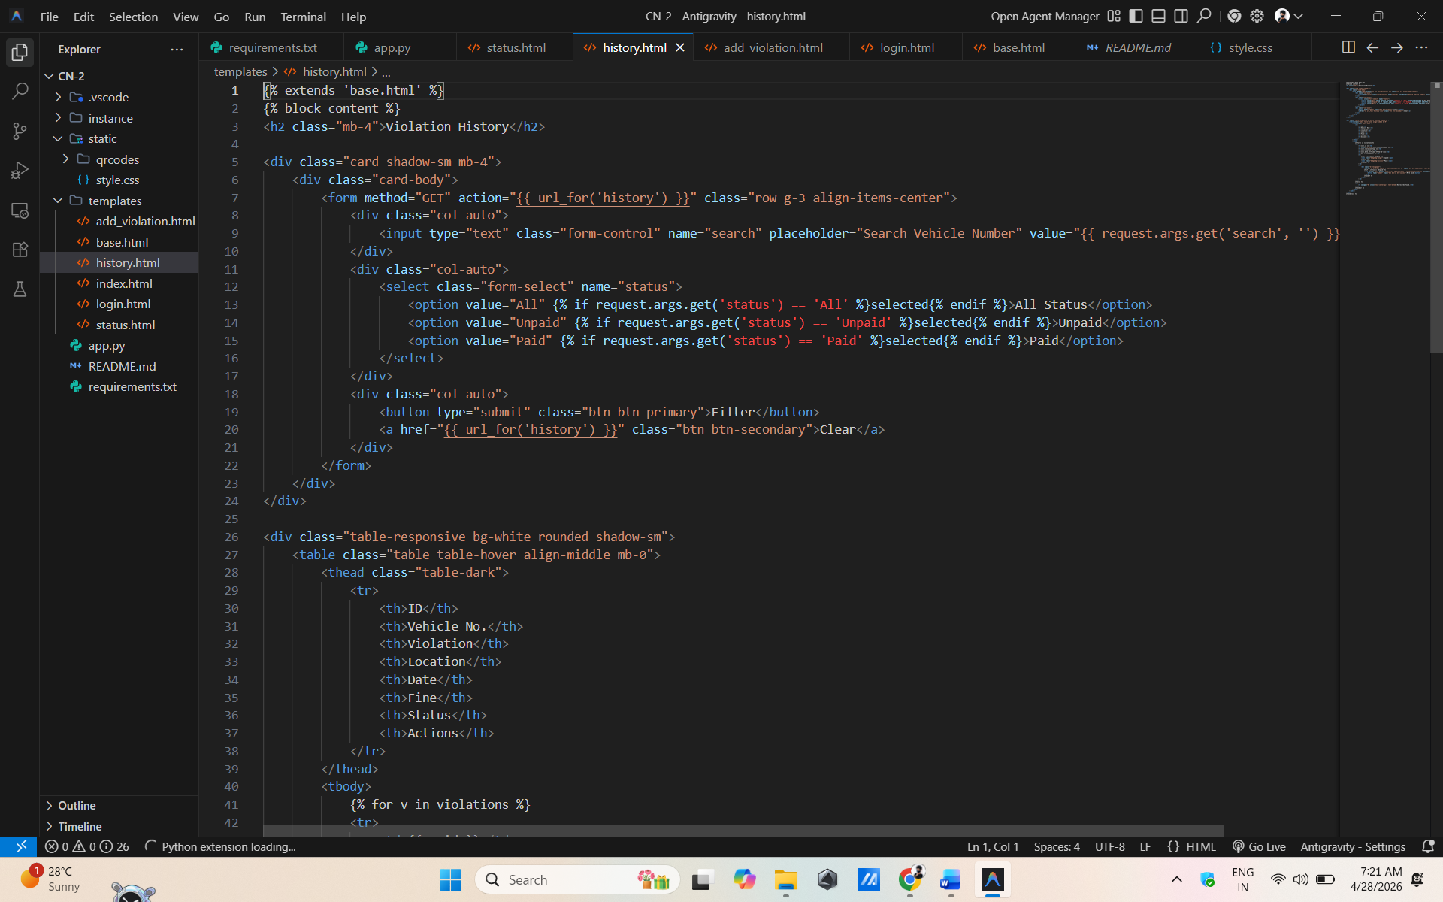

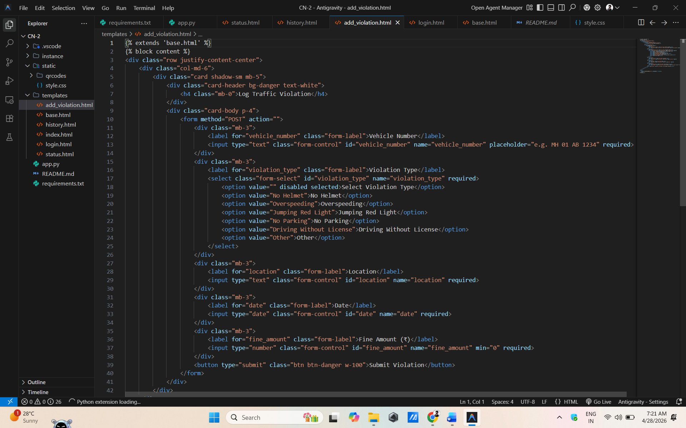

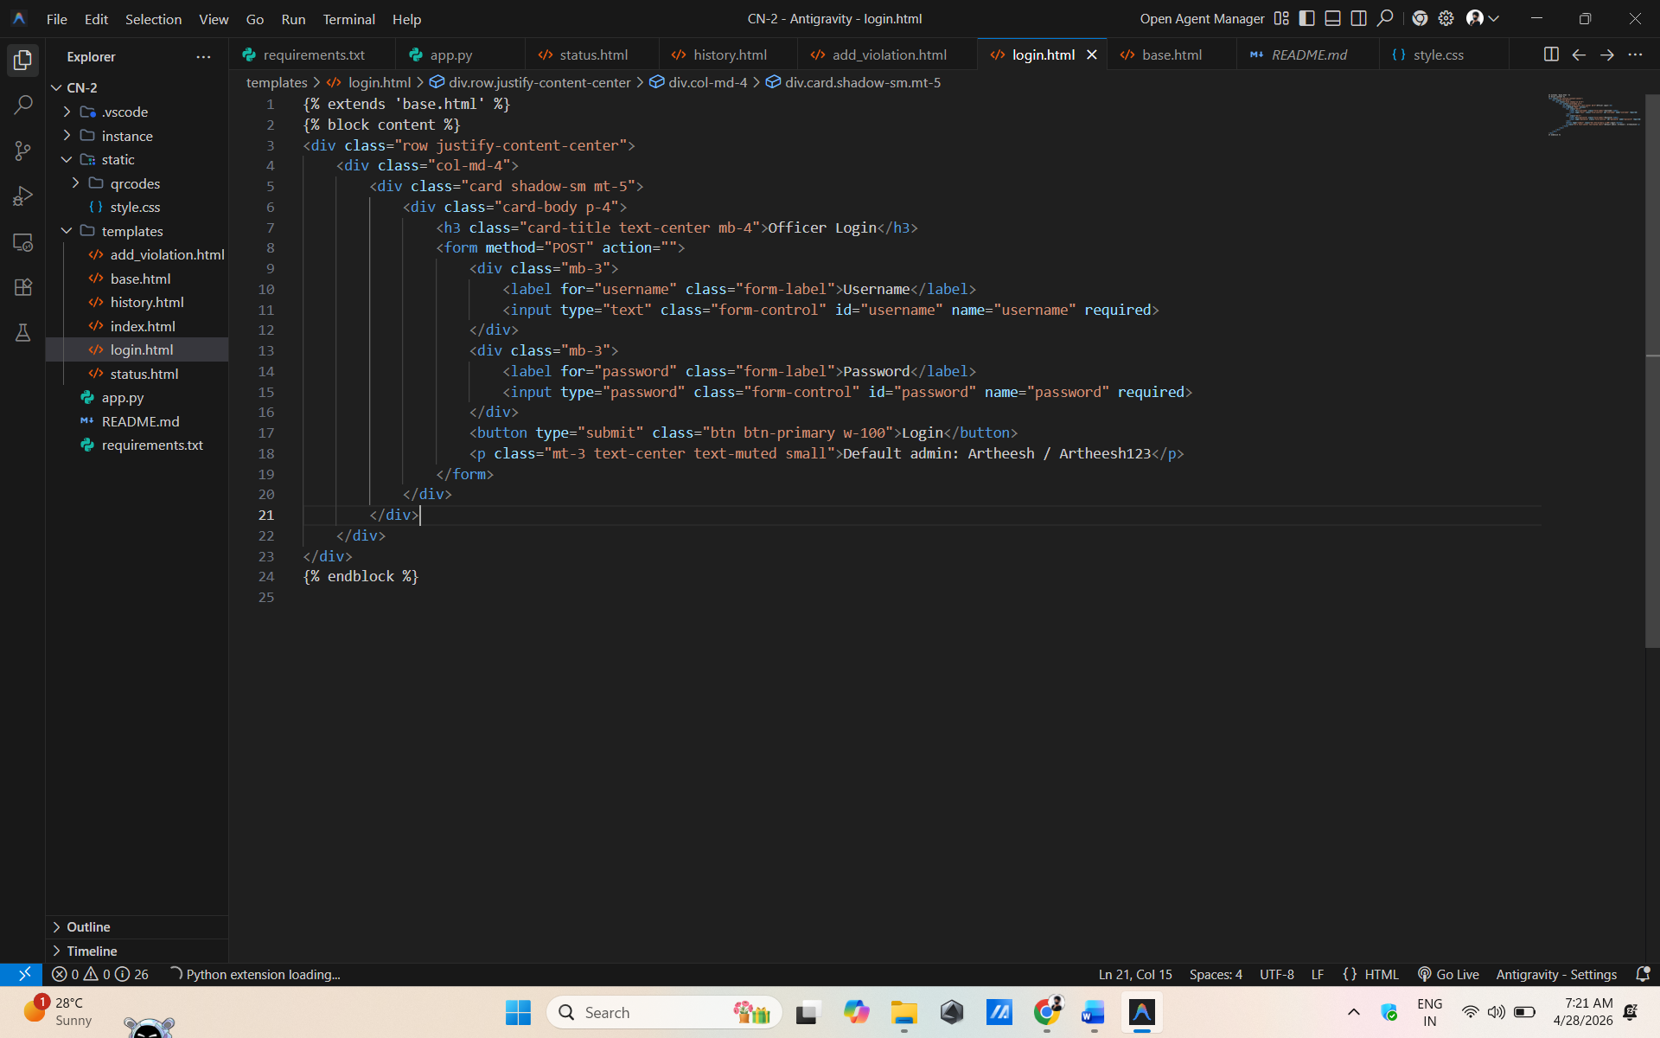

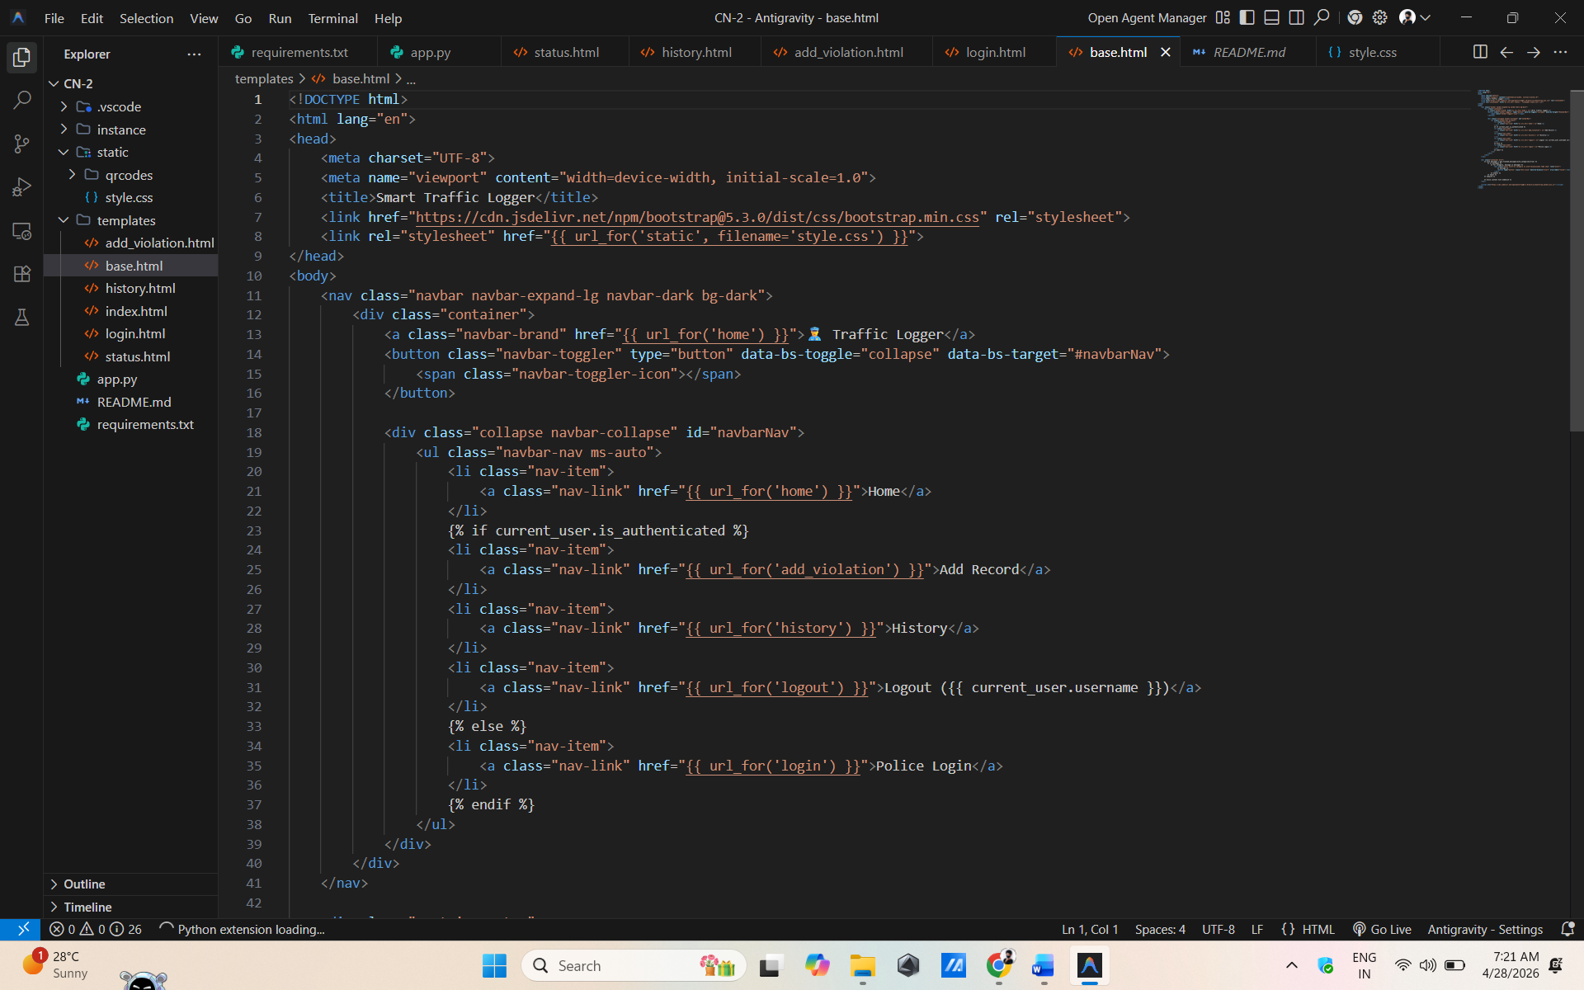

RESULT
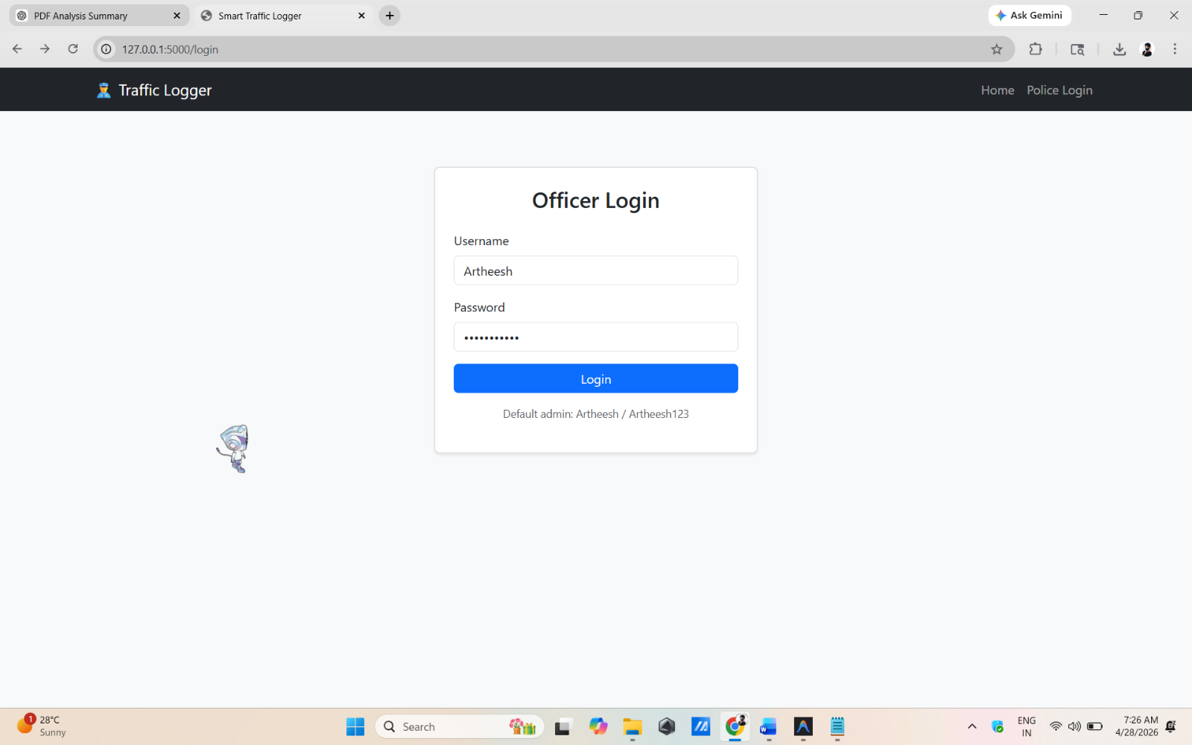

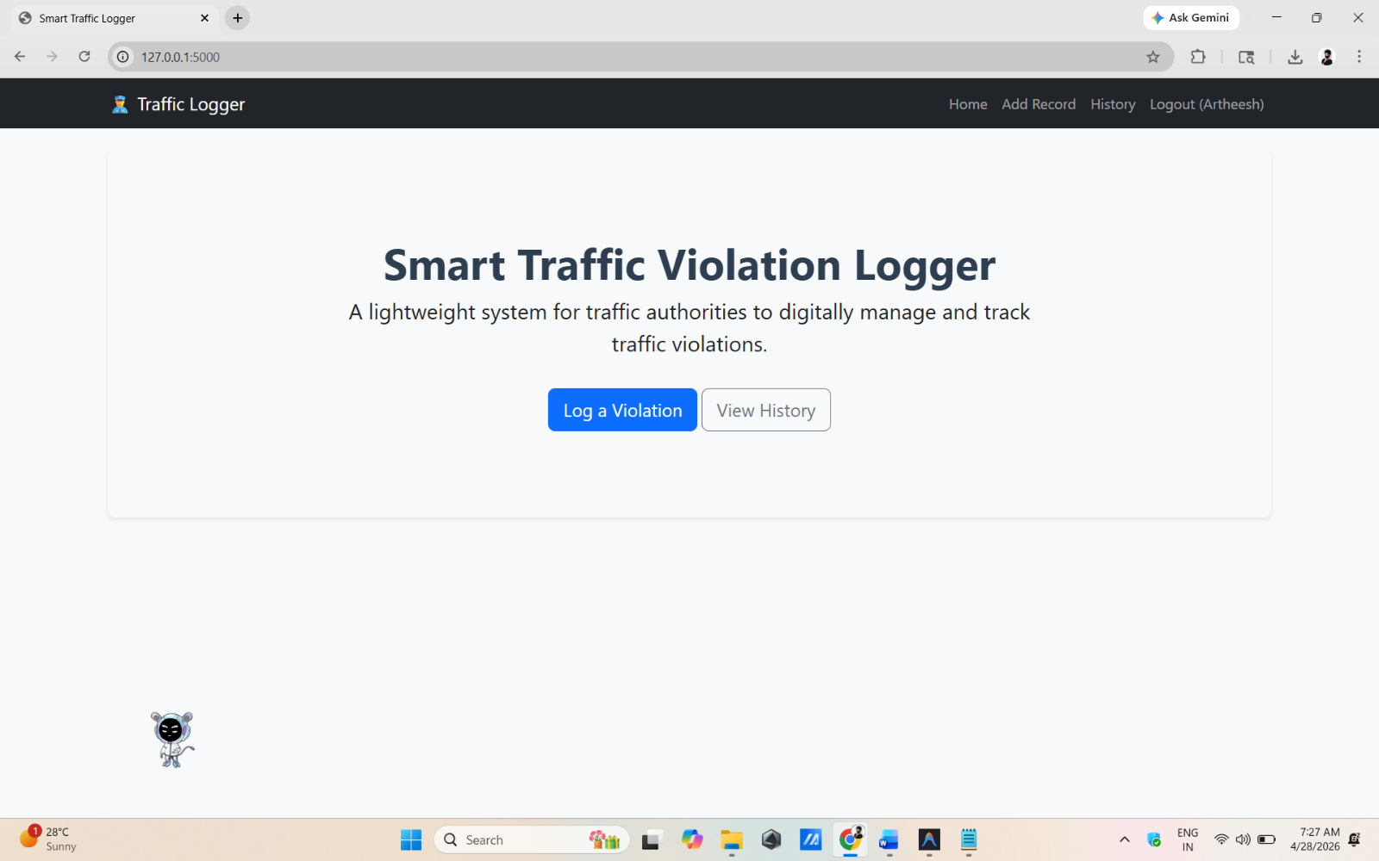

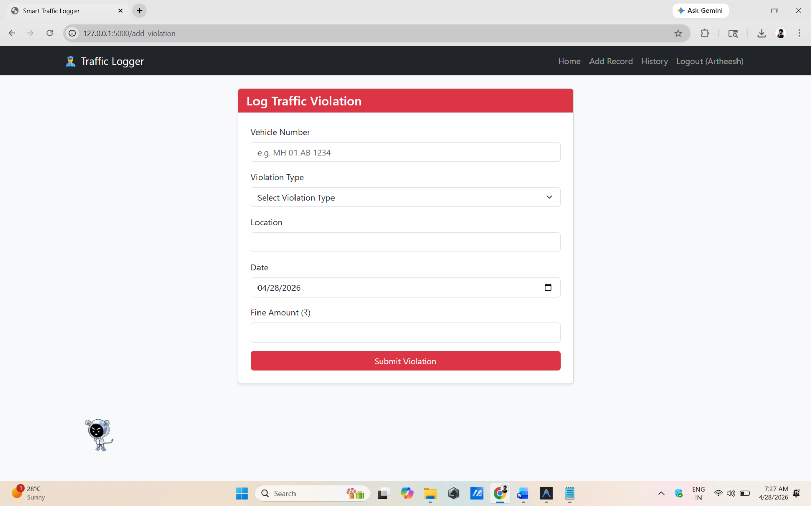

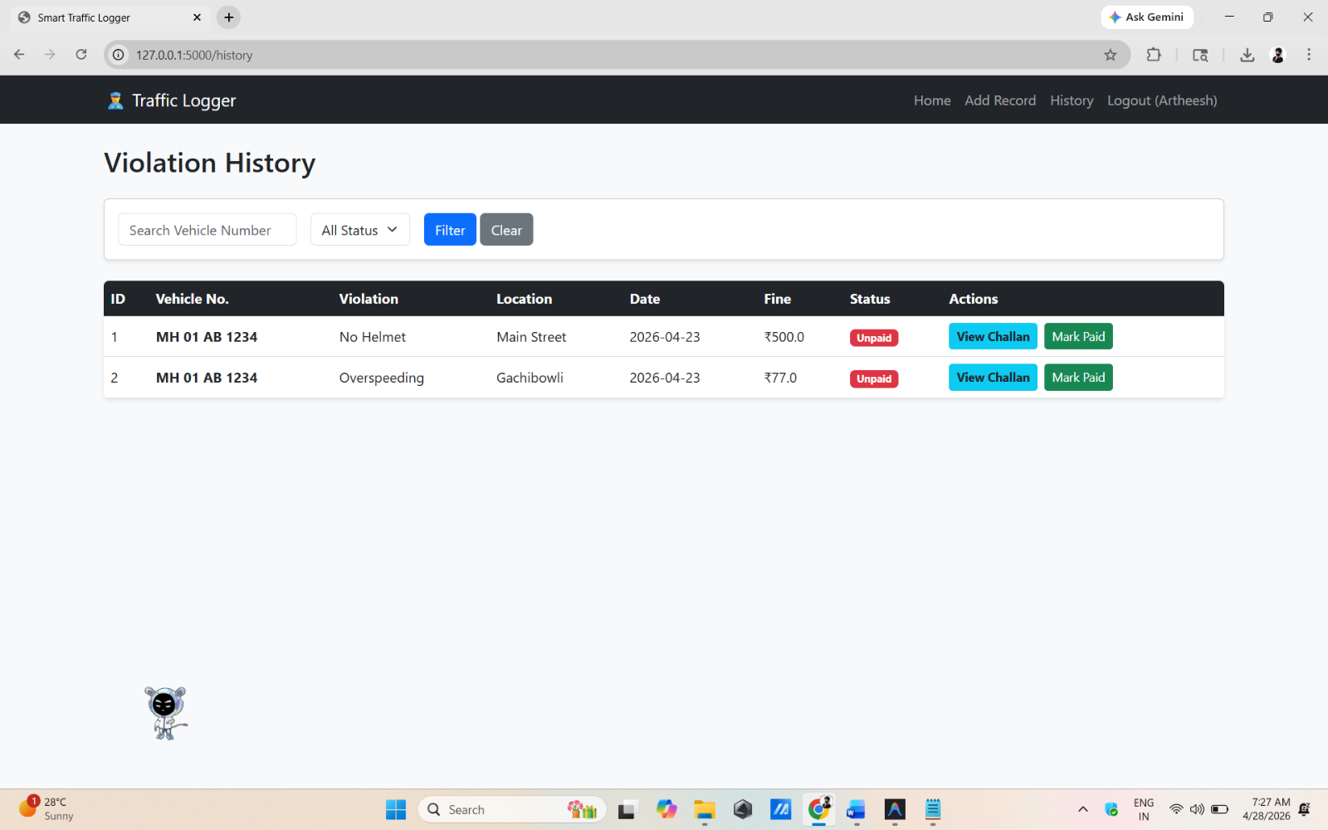

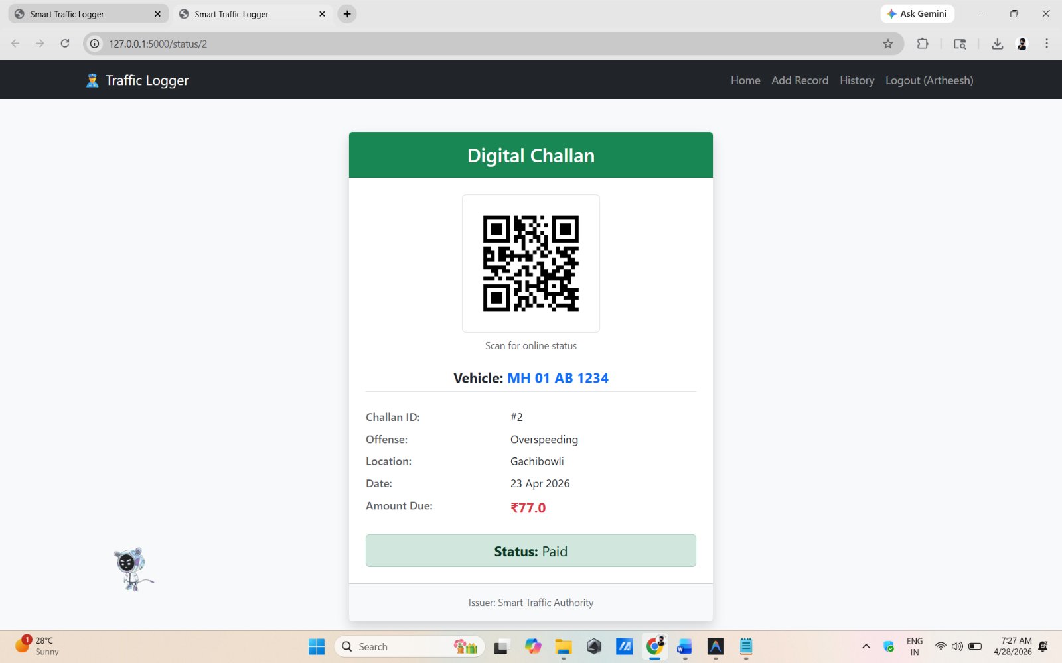

4. System Features & User Interface
The Smart Traffic Violation Logger with QR-Based Challan System includes the following key features:
🔹 Add Violation Record
Traffic officers can enter details such as vehicle number, violation type, location, date, and fine amount. Each record is automatically stored and marked as Unpaid.
🔹 View & Search Records
Users can quickly search violation history using the vehicle number. Filters such as date, violation type, and payment status help in efficient data retrieval.
🔹 Update Payment Status
The system allows updating the status of a violation from Unpaid to Paid, ensuring accurate tracking of fines.
🔹 QR Code-Based Challan
A unique QR code is generated for every violation. Scanning the code redirects to a public page showing violation details and payment status.
🔹 Admin Access (Optional)
A secure login system can be added to restrict access, ensuring only authorized officers can add or modify records.

User Interface
🔹 Design
The interface is built using Bootstrap, providing a clean, responsive, and user-friendly layout that works across devices.

🔹 Main Pages
- Add Violation Page
Simple form interface for entering violation details.
- Search/View Page
Displays records in a structured table with search and filter options.
- Status Page (QR View)
Public page showing violation details when QR code is scanned.
- Admin/Login Page (Optional)
Secure login interface for authorized users.

🔹 UI Characteristics
- Easy navigation between pages
- Responsive layout (mobile + desktop)
- Clear forms and tables for better usability
- Minimal and clean design for quick access

5. Project Outcomes
The Smart Traffic Violation Logger with QR-Based Challan System successfully delivers a functional web application for managing traffic violations in a digital format.

🔹 Key Outcomes
- Efficient Violation Management
Enables quick and organized recording of traffic violations, reducing manual effort and errors.
- Centralized Data Storage
All records are stored in a database, making it easy to access, update, and manage violation history.
- Improved Transparency
QR code-based challan system allows users to instantly view violation details and payment status.
- Real-Time Status Tracking
Officers can update and monitor payment status (Paid/Unpaid) effectively.
- User-Friendly Interface
A simple and responsive UI ensures ease of use for both authorities and the public.
- Practical Implementation of Concepts
Demonstrates real-world application of Flask, database integration, CRUD operations, and QR code generation.

6. Conclusion
The Smart Traffic Violation Logger with QR-Based Challan System provides an efficient and practical solution for digitizing traffic violation management. By replacing manual processes with a web-based system, it simplifies the recording, tracking, and updating of violation records while improving accuracy and transparency.
The integration of QR code technology enhances accessibility by allowing users to quickly view challan details and payment status. The project also demonstrates the effective use of Flask, database management, and CRUD operations in building a real-world application.
Overall, this system serves as a strong foundation for modern traffic management and can be further enhanced with advanced features such as online payment integration, AI-based detection, and large-scale deployment.

